T-1450-15

FEDERAL COURT OF CANADA

BETWEEN:

Radu Hociung

Plaintiff

and

Minister of Public Safety and Emergency Preparedness

Defendant

MOTION RECORD

Radu Hociung

246 Southwood Drive

Kitchener, Ontario

N2E 2B1

Tel: (519) 883-8454

Fax: (226) 336-8327

email: radu.cbsa@ohmi.org

TO:

The Registrar

Federal Court of Canada

180 Queen Street West

Suite 200

Toronto, Ontario

M5V 3L6

AND TO:

Eric Peterson, Counsel to the Defendant

DEPARTMENT OF JUSTICE

Ontario Regional Office

The Exchange Tower

130 King St. West

Suite 3400, Box 36

Toronto, Ontario

INDEX

TAB 1 3

NOTICE OF MOTION 4

TAB 2 6

WRITTEN REPRESENTATIONS 7

TAB 3 16

Exhibit “A” 16

TAB 4 25

Exhibit “B” 25

FORM 359 - Rule 359

NOTICE OF MOTION

T-1450-15

FEDERAL COURT OF CANADA

BETWEEN:

Radu Hociung

Plaintiff

and

Minister of Public Safety and Emergency Preparedness

Defendant

NOTICE OF MOTION

TAKE NOTICE THAT the plaintiff will make a motion to the Court in writing under Rules 227, 232, 97(d), of the Federal Courts Rules.

THE MOTION IS FOR:

- An Order that the Defendant produce all documents he designated as solicitor-client privileged in his affidavit of documents as listed in Exhibit “A”.
- An Order that the documents purporting to originate with employees of the CBSA, and provided in the Defendant's Affidavit of Documents be admissible as evidence at trial, as listed in Exhibit “A”.
- His costs of this motion; and
- Such other relief as this Honourable Court deems just.

THE GROUNDS FOR THE MOTION ARE:

- The Defendant incorrectly claimed solicitor-client attorney privilege on several memorandums and emails, as there the Legal Services Unit acted as a business counsellor. If any privilege did exist, it has been lost due to voluntary disclosure by the defendant.
- The Defendant has failed to answer proper questions within the time allowed for written examination for discovery.
- The Defendant is at refusing to communicate, answer discovery questions, and produce documents as part of discovery, in order to prevent their use as evidence at trial.

THE FOLLOWING DOCUMENTARY EVIDENCE will be used at the hearing of the motion:
- The record of the proceeding.
- Exhibits “A” and “B” herein.
- The pleadings herein.

DATE: January 31, 2018


______________________________

Radu Hociung

246 Southwood Drive

Kitchener, Ontario

N2E 2B1

Tel: (519) 883-8454

Fax: (226) 336-8327

email: radu.cbsa@ohmi.org

TO:

Eric Peterson, Counsel to the Defendant

DEPARTMENT OF JUSTICE

Ontario Regional Office

The Exchange Tower

130 King St. West

Suite 3400, Box 36

Toronto, Ontario

FEDERAL COURT OF CANADA

BETWEEN:

Radu Hociung

Plaintiff

and

Minister of Public Safety and Emergency Preparedness

Defendant

WRITTEN REPRESENTATIONS

OVERVIEW

- This action was brought on August 28th, 2015, to challenge seizure of several United States Treasury gold and silver coins by the CBSA.
- The defendant served his Affidavit of Documents on November 9th, 2015.
- Written discovery questions were served to the Defendant on July 19th, 2016.
- On August 30th, 2016, the Plaintiff wrote to the Court to request the case be specially managed, as the Defendant had failed to respond to discovery questions within 30-days as per Rule 99(4)
- At about the same time, the Defendant filed a motion to strike the Statement of Claim in its entirety.
- Both the Defendant's motion and and the Plaintiff's request for Case Management were considered by Madam Prothonotary Martha Milczynski on September 21st. The motion was denied, and the request for Case Management was granted.
- In her Order, the Prothonotary noted that some of the Defendant's own representations go to the merits of the appeal.
- On November 9th, 2016, Mr. Prothonotary Kevin Aalto was assigned as Case Management Judge.
- On December 22nd, 2016, at the first Case Management Conference, Mr Prothonotary Aalto ordered the Defendant to provide written answers to the interrogatories by Jan 31st, 2017, and to conduct oral discoveries on the Plaintiff on Jan 5th, 2017.
- On January 31st, 2017, the Defendant provided complete answers to 19 of the 40 questions in the written examination, but responded to 10 with an objection statement, and no preliminary answer; 5 were non-responsive, where the answer did not relate to the question and 6 answers gave rise to further questions.
- On February 2nd and 7th, 2017, the Plaintiff served the Defendant follow-up questions arising from his answers, as well as a reminder that any objections he has must be made as per Rules 94, 95 and 99, ie by bringing motions. Stating “objection” in lieu of an answer is not a proper way to object.
- On February 20th, 2017, the Plaintiff brought a motion for leave to amend the statement of claim, based on answers the Defendant provided on January 31st. This motion is still pending.
- On March 1st, 2017, the day before a scheduled CMC, the Defendant filed a Motion for Summary judgement, with the text of the motion being largely identical to his August 30th, 2016 motion to strike the statement of claim. This motion is still pending.
- The Motion for Summary Judgement included the representations that drew Madam Prothonotary Milczynski's observation that the motion supports the appeal.
- Subsequent CMC were held on March 2nd, 2017, November 14th, 2017 and December 18th, 2017.
- On March 2nd and November 14th, the Plaintiff requested the Case Management Judge to order the Defendant to respond to outstanding discovery questions, but the CM Judge refused.
- On November 23rd, 2017 the defendant brought a motion appealing the CM Judge's decisions to hold the proceedings in abeyance indefinitely, and to cease case managed mode.
- On December 14th, 2017, Mr Justice Zinn cosidered the motion apealing the Prothonotary orders, and dismissed it, and directed the Registry that the motions for Summary Judgement and Leave to Amend the Statement of Claim be placed before a judge forthwith.
- On December 18th, 2017, Mr. Prothonotary Aalto ordered that the proceeding cease to be specially managed, and continue normally.
- As of the date of this motion record, the defendant has not yet provided any answers to the February 2016 questions. The plaintiff's motion to amend the claim, and the defendant's motion for summary judgement are still pending with the Court.

- The discovery answers obtained so far were so incriminating, that a claim of facilitating money laundering by the CBSA is needed to be amended to the Statement of Claim. There is reason to believe that the unanswered questions will lead to other similarly serious claims being amended to the Statement of Claim.

FACTS

- On October 21st, 2014, the plaintiff entered Canada with several gold and silver United Stated coined issued by the US Treasury pursuant United States Code 31 “Money and Finance”, sections 5112(a)(11) and 5112(e), as legal tender circulation currency.
- Upon random inspection, the CBSA ruled that the coins should have been declared as goods, seized them, and offered Terms of Release in the sum of $1606.97, or 25% of the value of the metals contained in the coins.
- On October 23, 2014, the plaintiff appealed the seizure and requested a Ministerial Decision pursuant Customs Act section 129.
- On June 1st, 2015, the Minister delivered his Decision, lowering the Terms of Release to $321.39, but maintaining that the coins are “goods”, and that a non-report contravention was committed.
- In his Decision, the reason the Minister gave is that the US coins are not 'cash' as defined by the Proceeds of Crime (Money Laundering) and Terrorist Financing Regulations [ PCMLTFR ], and therefore they are considered 'goods'.
- The PCMLTFR definition of “Cash” is:

“cash” means coins referred to in section 7 of the Currency Act, notes issued by the Bank of Canada pursuant to the Bank of Canada Act that are intended for circulation in Canada or coins or bank notes of countries other than Canada. (espèces)
- During the period between the October 23 2014 when the Minister's decision was requestd and June 1, 2016 when the Minister rendered his decision, various correspondence between the CBSA Recourse Directorate and the Plaintiff was exchanged.
- On March 9, 2015, M Gagnon, a senior appeals officer with the CBSA Recourse Directorate, wrote to the plaintiff to inform of an opinion that the Legal Services Unit [ LSU ] of the CBSA rendered, in which by “statutory interpretation” the CBSA concluded that the coins are not “cash”. The letter is enclosed as exhibit “B”.

- The CBSA March 9th 2015 letter, making reference to the LSU opinion was also disclosed in the Defendant's Affidavit Schedule 1 (non-priviledged documents), enclosed as exhibit “A”.
- In his affidavit of documents, the Defendant claimed solicitor-client privilege over several memos and email exchanges between members of the CBSA Recourse Directorate and members of the LSU, dated between February 12, 2015 and May 5, 2015. The affidavit of documents, not including copies of the non-privileged documents, is enclosed as exhibit “A”.
- The CBSA is a crown corporation, established under the Canada Border Services Act [CBSAA] s.3, and has the mandate of supporting the administration and enforcement of multiple Acts of Parliament, among which are the Customs Act [CA] and the Proceeds of Crime (Money Laundering) and Terrorist Financing Act [PCMLTFA].
- The Minister of Public Safety and Emergency Preparedness is the defendant in this action, and responsible for the CBSA, under CBSAA s.6.
- The business of the CBSA is the administration of various Acts of Parliament.
- The CBSA's organization includes a Recourse Directorate, which is responsible for handling appeals brought under the various Acts.
- The Recourse Directorate is staffed with paralegal staff and other officers and administrative staff, but not with lawyers.
- The LSU is another department of the CBSA, is staffed mainly with lawyers, and acts as an adviser to the Recourse Directorate, providing interpretations of the Acts, and legal opinions, in order to assist the Recourse Directorate in providing reasons for various enforcement actions.
- Under the Crown Liability and Proceedings Act, the solicitor for agents of the Crown is the General Attorney of Canada.

MEMORANDUM OF LAW
- Under Criminal Code, s. 462.31, Money Laundering is a serious offence, punishable with up to 10 years imprisonment.
- Failure to report currency or financial instruments imported or exported from Canada is an indictable offence, punishable with up to 5 years imprisonment.
- Under the Criminal Code, a “serious offence” is an indictable offence under any Act of Parliament, for which the maximum punishment is imprisonment five years or more.
- Under Criminal Code, s. 467.11, facilitating indictable crimes is itself an indictable crime, punishable with up to five years of imprisonment.
- In Susan Hoisery , the judge found that documents that must be proven at trial must be disclosed, and are not protected by solicitor-client privilege.
- Solicitor-client privilege arises only when the following factors are present:
  - The communication must be between a solicitor and client. Even in absence of a formal retainer, criteria that have to be met are set in Descôteaux
  - The communication must be made in confidence, as set in Sopinka
  - The communication must be made in the course of seeking legal advice. It does not apply when the lawyer is acting as a business counsellor as set in Sopinka and Blood Tribe
- Where solicitor-client exists, it is lost in the following circumstances:
  - When the holder of the privilege makes a voluntary disclosure of any material part of the privileged communication, such as by referring to them in Schedule 1 to an affidavit of documents. If privilege is waived, all documents relating to the communication need to be disclosed
  - Where a party puts his “state of mind” in issue in the pleadings, and the state of mind was informed by legal advice, solicitor-client privilege is deemed to have been waived. When a party relies on legal advice, he/she cannot in fairness be permitted to use privilege to prevent the other party from exploring its validity

SUBMISSIONS
- With respect to the facts in this action, the LSU's role is one of business advisor to the the Recourse Directorate, advising of the interpretation of Acts, in order to aid the Directorate in administering the Acts.
- The LSU is not, and cannot be the solicitor for the defendant, or the CBSA, or other civil servants, as this role is reserved under the Crown Liability Act, to the General Attorney.
- The LSU's role in this proceeding is not one of solicitor, but one of expert, or business advisor, providing expertise that the Recourse Directorate does not posses (interpretation of the Acts being administered).
- The LSU's opinion as to the classification of the coins is an interpretation of Acts, or an expert opinion, intended to be provided as reasons to the plaintiff. It is not legal advice given by a solicitor to his client.
- Solicitor-client privilege does not exist, as the LSU is acting in a solicitor role in this proceeding, between the LSU and the Recourse Directorate, and thus the documents marked as privileged in schedule 2 of the Defendant's affidavit of documents must be disclosed.
- The opinion rendered by the LSU to the Recourse Directorate is relevant to the case, and must be proven at trial, thus the defendant is bound to give discovery of them, as ruled in Susan Hosiery Ltd
- Should the court determine that a solicitor-client relationship does exist between the LSU and the Recourse Directorate, privilege has been expressly waved by M. Gagnon's voluntary disclosure of the LSU's opinion in her March 9th, 2015 letter (exhibit “B”).
- The Minister's delegate relied on the LSU opinion in arriving at his decision that makes the subject of this action. The Minister's delegate is effectively in the “state of mind” that currency of the United States is not “cash” according to the PCMLTFR, that is, it does not match the “coins of countries other than Canada” of that definition. This state of mind needs to be proven at trial, and fairness dictates that the plaintiff be entitled to exploration of its validity
- In case the relationship between LSU and the Recourse Directorate is deemed by the Court to be a solicitor-client relationship, the opinion disclosed by M Gagnon in her March 9, 2015 either advised or caused her to understand that the coins in question, which are currency of the United States, do not need to be reported under PCMLTFA.
- The opinion rendered by the LSU, that the US currency in question is “goods” and need not be reported under PCMLTFA amounts to an advice to not report under s.12 of PCMLTFA, which is an indictable offence per s. 74 of the PMCLTFA, punishable by imprisonment up to five years.
- The CBSA view that this kind of currency is not to be reported under s.12 of the PCMLTFA is what brought this action about, and thus it can be understood that the advice sought from the LSU was to facilitate the commission of a crime, as non-reporting of currency imported into Canada is an indictable offence per s.74 of the PCMLTFA.
- The “statutory interpretation” that the LSU provided is not clear as to which statute is being interpreted, nor an explanation of the interpretation itself. The “statutory interpretation” is therefore a “state of mind” of the LSU and the Recourse Directorate. This state of mind was a major factor in the Minister's decision, and thus according to the principles of fairness, the plaintiff must be allowed to understand how the state of mind was formed.
- In seizing the coins on October 21, 2014, CBSA officer Debski committed fraud over $5000, by misrepresenting that US currency was goods. M Gagnon, as the second Recourse Directorate adjudicator assigned to the appeal, sought to uphold officer Debski's fraud, and to defraud the plaintiff of $1606.97 as representing “Terms of Release” of the coins. The LSU's opinion was sought for this purpose, ie, for the purposes of supporting a fraud, and committing a further one.
- Whether the LSU's advice itself was criminal, or it was sought in order to enable a crime is not important. In either case, the communication between the LSU and the Recourse Directorate with respect to the facts in this action are not protected by solicitor-client privilege.
- At this point in time, the defendant's answers to discovery have been outstanding for about 18 months. No objection motions have been filed seeking to strike any of the questions, and the time for filing such objections has long passed. The defendant had 30 days from the time he was served with the questions to either object or answer them, according to Rule 99.
- By refusing to answer discovery questions, the defendant is denying production of documents originated within CBSA, and disclosed in his affidavit of documents schedule 1 as “non-privileged. By refusing production, he seeks to prevent their use as evidence at trial.

ORDER SOUGHT
- The plaintiff requests ORDERS:
  - The defendant produce all documents listed in Schedule 2 of his affidavit of documents (“privilege claimed”, which is enclosed as exhibit “A”.
  - Documents originating within the CBSA which were disclosed in the defendant's affidavit of documents be admissible at trial, without being produced expressly by the defendant as answers to discovery; Alternately, an order that he produce all documents referred within as evidence.
  - The defendant be ordered to answer discovery questions immediately, or expedited, within 5 business days of the order, without leave to file motions of objection.
  - His costs on this motion..

ALL OF WHIICH IS RESPECFTULLY SUBMITTED

DATE: January 31, 2018

______________________________

Radu Hociung

246 Southwood Drive

Kitchener, Ontario

N2E 2B1

Tel: (519) 883-8454

Fax: (226) 336-8327

email: radu.cbsa@ohmi.org

TO:

Eric Peterson, Counsel to the Defendant

DEPARTMENT OF JUSTICE

Ontario Regional Office

The Exchange Tower

130 King St. West

Suite 3400, Box 36

Toronto, Ontario

Exhibit “A”
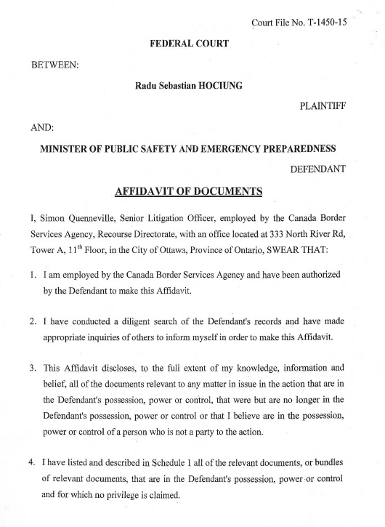
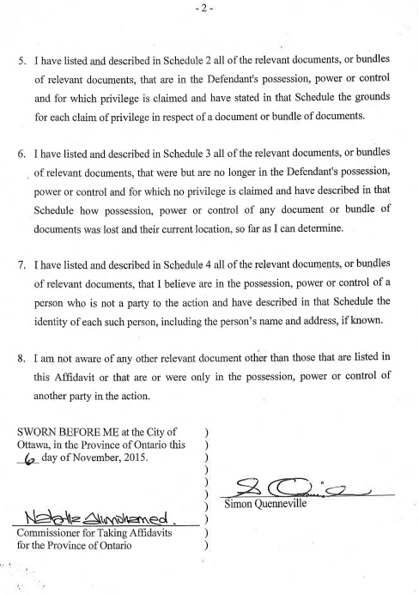
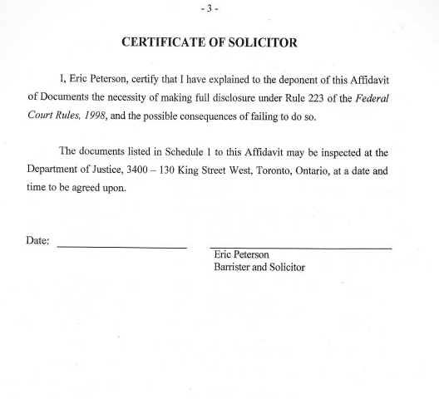
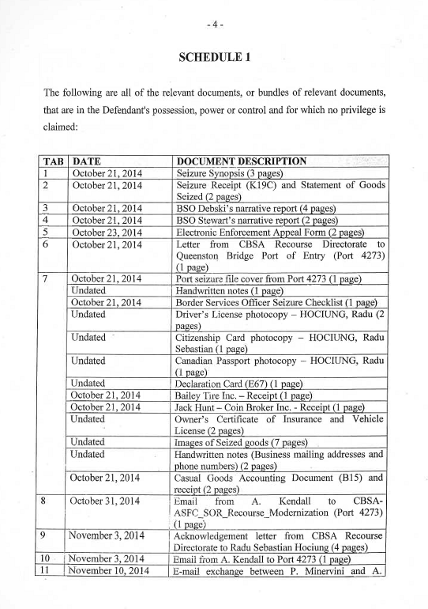
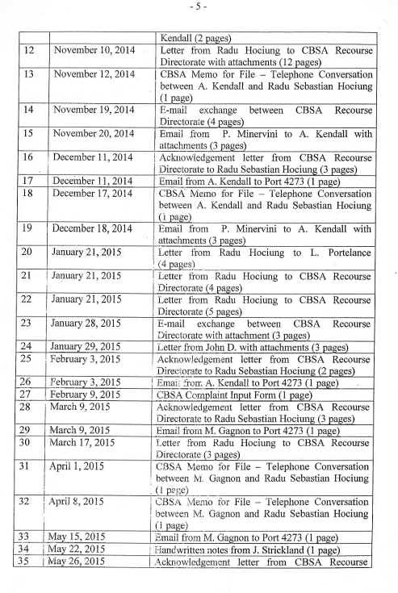
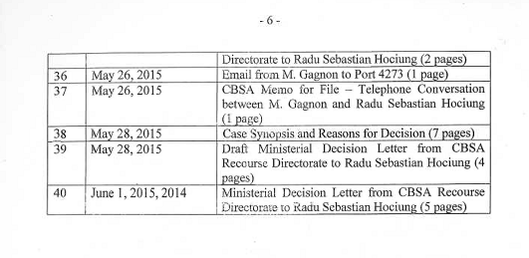
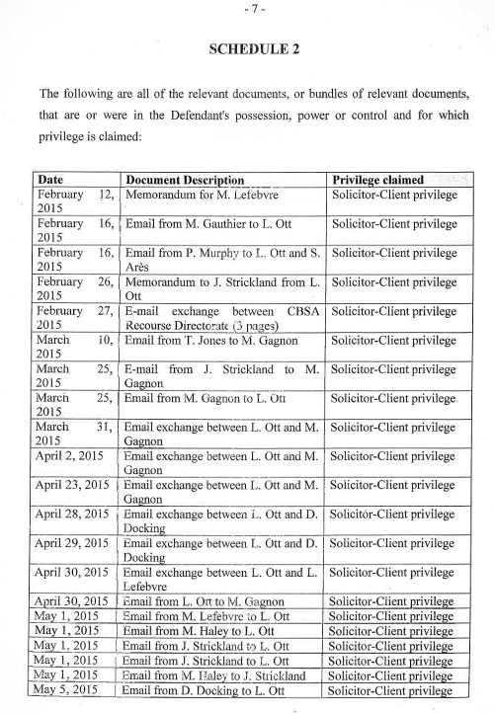
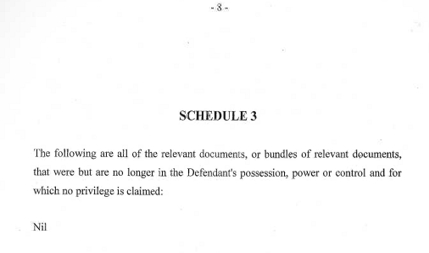
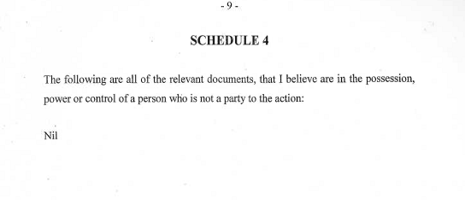

Exhibit “B”

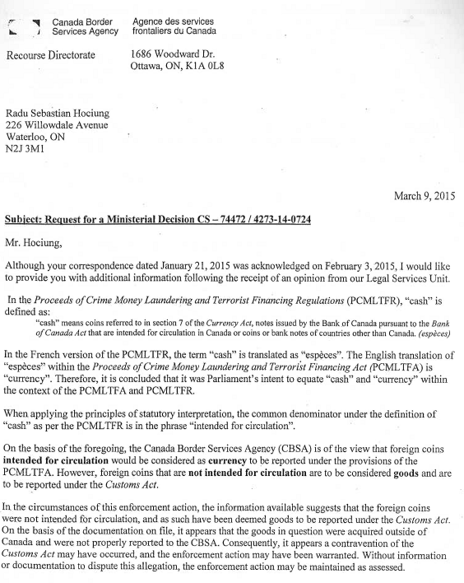
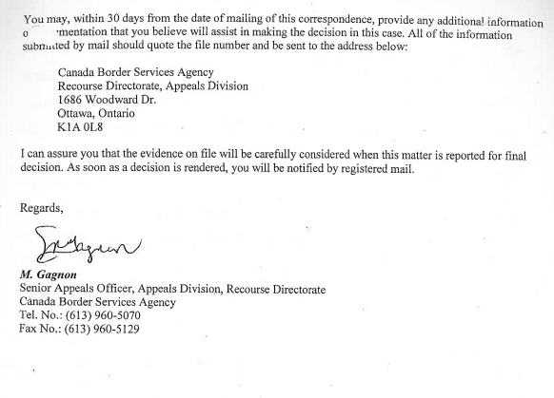

Susan Hosiery Ltd. v. M.N.R., [1969] D.T.C. 5278 (Ex. Ct.)
Descôteaux v. Mierzwinski, [1982] 1 S.C.R. 860 [“Descôteaux”]
Sopinka, Lederman and Bryant, The Law of Evidence in Canada, 3rd ed. at para. 14.48 [“Sopinka”]
Ibid. at para. 14.71; Canada (Privacy Commissioner) v. Blood Tribe Department of Health, [2008] 2 S.C.R. 574 [“Blood Tribe”], at para. 10
Sopinka, supra, fn. 3, at para. 14.122.
Re Briamore Manufacturing Ltd., [1986] 1 W.L.R. 1429.
Sopinka, supra, fn. 3, at para. 14.122.
S&K Processors Ltd. v. Campbell Ave. Herring Producers Ltd. (1983), 35 C.P.C. 146 at para. 6 (B.C.S.C.).
Susan Hosiery Ltd., supra, fn 1
S&K Processors Ltd. v. Campbell Ave. Herring Producers Ltd. (1983), 35 C.P.C. 146 at para. 6 (B.C.S.C.).
Podrebarac and Bida, Keeping Secrets and Protecting Confidential Documents and Information in Litigation, (2010) 37 Adv. Q., p. 215; [“Bida”] Descôteaux, supra fn. 2 at p. 881
Bida, supra fn 11, p. 215; Descôteaux, supra fn. 2 at p. 881

